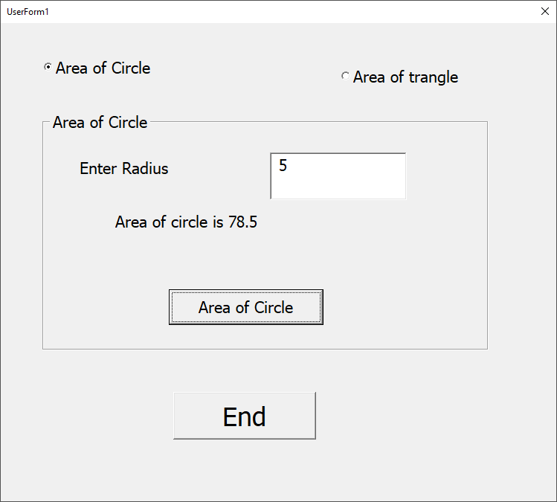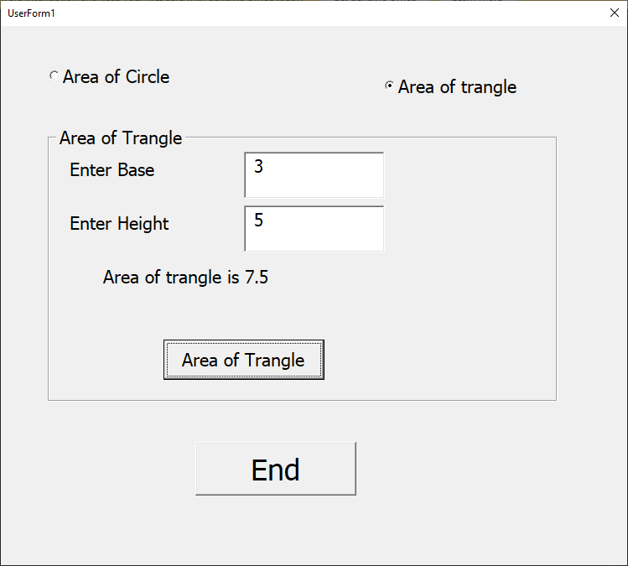**Design View:**

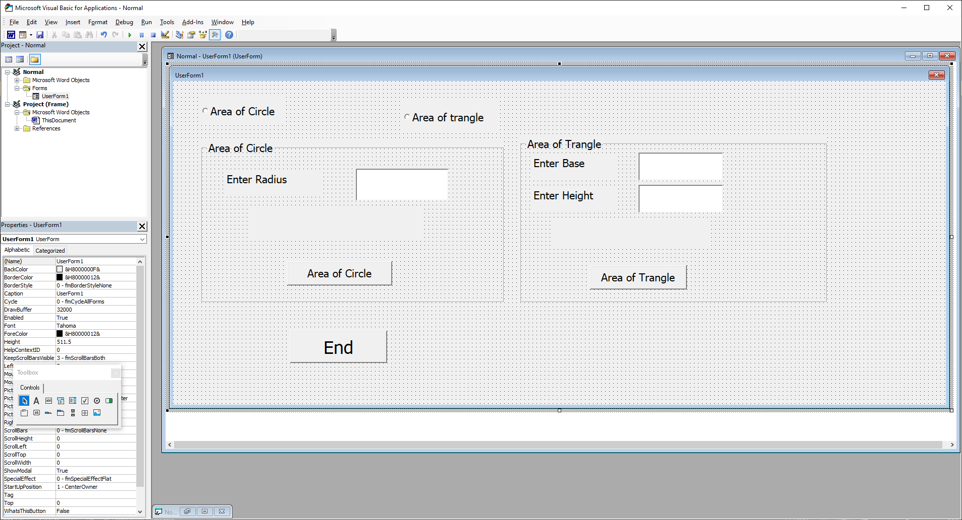

**Runtime View 2:**

**Runtime View 1:**

r = Val(txtR.Text)

area = 3.14 * r * r

lblAOC.Caption = "Area of circle is " & area

End Sub

Private Sub cmdAOT_Click()

Dim b As Integer, h As Integer, area As Double

b = Val(txtB.Text)

h = Val(txtH.Text)

area = 0.5 * b * h

lblAOT.Caption = "Area of trangle is " & area

End Sub

Private Sub cmdEnd_Click()

End

End Sub

Private Sub optAOC_Click()

fmeAOC.Visible = True

fmeAOT.Visible = False

End Sub

Private Sub optAOT_Click()

fmeAOC.Visible = False

fmeAOT.Visible = True

End Sub

Private Sub UserForm_Activate()

fmeAOC.Visible = False

fmeAOT.Visible = False

End Sub